CHAPTER 1
INTRODUCTION
  - Motivation
In many hospitals, several operations such as patient registration, appointment management, laboratory testing, and billing are still performed manually. This manual approach leads to problems such as excessive paperwork, difficulty in maintaining patient records, delays in retrieving information, and a higher chance of human errors. Managing different hospital departments separately also creates communication gaps between staff members, which can affect the efficiency and quality of healthcare services provided to patients.

The motivation behind developing the Hospital Management System (HMS) is to provide a centralized and computerized platform that automates hospital operations and improves overall efficiency. The system helps manage various activities such as patient registration, doctor consultation, laboratory test management, patient admission and discharge, and billing processes. By integrating these functions into a single system with roles such as Admin, Registration Staff, Doctor, Lab Staff, and Billing Staff, the system reduces paperwork, improves data accuracy, and enables faster and more organized healthcare service management.

  - Project Scope
The Hospital Management System (HMS) is designed to digitize and manage the daily operations of a hospital through a centralized web-based platform. The system focuses on automating major hospital processes such as patient registration, appointment scheduling, doctor consultation, laboratory testing, patient admission and discharge, and billing management. It allows hospital staff to efficiently store, retrieve, and manage patient information while reducing manual paperwork and improving the accuracy of hospital records.

  - Project Stakeholders
The project stakeholders for this document are:
- Admin
- Registration
- Doctor
- Lab Desk
- Bill Desk

  - Project Scheduling
Phase | Tasks | Duration
Week 1-2 | Requirement Analysis & Feasibility Study | 2 Weeks
Week 3 | System Design (ERD, DFD, UML Diagrams) | 1 Week
Week 4-6 | Database Design & Setup (MySQL/PostgreSQL) | 3 Weeks
Week 7-10 | Frontend Development (HTML, CSS, JavaScript) | 4 Weeks
Week 11-14 | Backend Development (Python/Java/PHP) | 4 Weeks
Week 15-16 | Integration & Testing | 2 Weeks
Week 17 | Deployment & Documentation | 1 Week
Week 18 | Final Review & Submission | 1 Week

CHAPTER 2
SYSTEM ANALYSIS

  - Introduction
The Hospital Management System (HMS) is developed to replace traditional manual hospital management processes with a centralized web-based application. In many hospitals, tasks such as maintaining patient records, managing doctor consultations, handling laboratory reports, and generating bills are performed manually, which can lead to errors, delays, and inefficient data management. The system provides a digital solution to store, update, and retrieve hospital information efficiently.

  - Requirement Analysis
    - Functional Requirement
Admin
- Authentication: Admin must be authenticated before accessing system.
- Manage Doctors: Admin can add, update, view, and delete doctor details in the system.
- Manage Patients: Admin can view and manage patient information stored in the system.
- Manage Rooms: Admin can add, update, and manage hospital rooms for patient admission.
- Manage Lab Tests: Admin can create and manage available laboratory tests in the system.
- View System Data: Admin can monitor overall hospital records and system activities.
Registration
- Authentication: Registration must be authenticated before accessing system.
- OPD Registration: Register new patients for outpatient department visits.
- Appointment Confirmation: Schedule and confirm appointments with doctors.
- Patient Admission: Admit patients into hospital rooms for IPD treatment.
- Manage Patient Records: View and manage patient registration information.
- Patient Discharge: Handle patient discharge process after treatment completion.

Doctor
- Authentication: Doctor must be authenticated before accessing system.
- View Patients: Doctor can view patient details and medical records.
- View IPD Patients: Doctor can view admitted patients assigned for treatment.
- Consult Patients: Doctor can consult OPD and IPD patients.
- Manage Prescription: Doctor can create and update patient prescriptions.

Lab
- Authentication: Lab must be authenticated before accessing system.
- View Patients: Lab staff can view patients assigned for laboratory tests.
- Manage Lab Reports: Create and manage laboratory reports.
- Update Test Results: Update laboratory test results for patients.

Billing
- Authentication: Bill must be authenticated before accessing system.
- View Patients: Billing staff can view patient details related to billing.
- Generate Bills: Create and manage patient billing records.
- Manage Payments: Record payment details and finalize patient bills.

    - Non-Functional Requirement
Performance Requirements
- The system should handle multiple users simultaneously without performance degradation.
- Patient data retrieval and search operations should return results within 2 seconds.
- Response time for operations such as patient registration, prescription generation, and billing should be less than 3 seconds.

Scalability
- The system should support the addition of new patients, doctors, laboratory tests, and billing records without requiring major system changes.
- The database should be capable of storing a large number of patient records and hospital data efficiently.

Security
- User authentication should be implemented using role-based access control (RBAC).
- Passwords should be stored using encryption techniques (e.g., bcrypt, SHA-256).
- Only authorized users (Admin, Registration Staff, Doctor, Lab Staff, Billing Staff) should access their respective modules.
- All system activities and transactions should be logged for auditing purposes.

    - Software & Hardware Requirements
User | Particulars | Client System | Server System
Hospital Staff (Admin, Registration, Doctor, Lab, Billing) | Operating System | Windows | Windows Server
 | Processor | Dual core (Minimum) | Intel i5 or higher
 | Hard disk | 250 GB (Minimum) | 1 TB (Minimum)
 | RAM | 4 GB (Minimum) | 80 GB
Members (Mobile App) | Operating System | Android 4.0 and Higher | -
 | Processor | Octa Core (Minimum) | -
 | Enteral Memory | 32 GB (Minimum) | -
 | RAM | 6 GB (Minimum) | -

  - Design and Implementation Constraints
The design and implementation of the Hospital Management System are subject to certain constraints that must be considered during the development and operation of the system. These constraints help ensure proper system functionality, secure handling of hospital data, and controlled access to different system modules.
Only authorized users such as Admin, Registration Staff, Doctor, Laboratory Staff, and Billing Staff are allowed to access the system through valid login credentials. Each user must keep their login information confidential to prevent unauthorized access. The system follows role-based access control, which ensures that users can access only those modules that are related to their assigned responsibilities.
The system depends on a stable internet connection for accessing and managing hospital information. Administrative tasks such as managing doctors, rooms, patients, and lab tests can be performed by the Admin, while other operations like patient registration, consultation, laboratory testing, and billing are handled by their respective roles. The system is designed to operate within defined software and hardware requirements and expects users to follow standard operational procedures for effective usage.
  - Assumptions and Dependencies
- A stable internet connection is required for communication between the client system and the server.
- Each user such as Admin, Registration Staff, Doctor, Lab Staff, and Billing Staff must have a valid login ID and password to access the system.
- The system assumes that all users will follow role-based access permissions and only perform operations assigned to their roles.
- The system depends on a centralized database server to store and manage hospital data such as patient records, prescriptions, laboratory reports, and billing information.
- All hospital staff are assumed to have basic computer knowledge to operate the system efficiently.
- The system assumes that the hospital will maintain proper data backup and system maintenance to prevent data loss.
- The application requires compatible web browsers such as Chrome, Firefox, or Edge for proper functionality.

CHAPTER 3
SYSTEM DESIGN

  - UML Diagram
    - Data-Flow Diagram
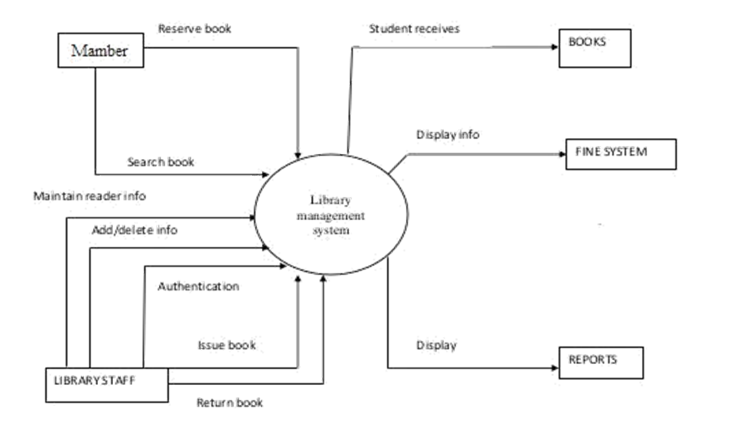
Figure 3.1.1.1 context diagram of library management system

    - Use-case Diagram
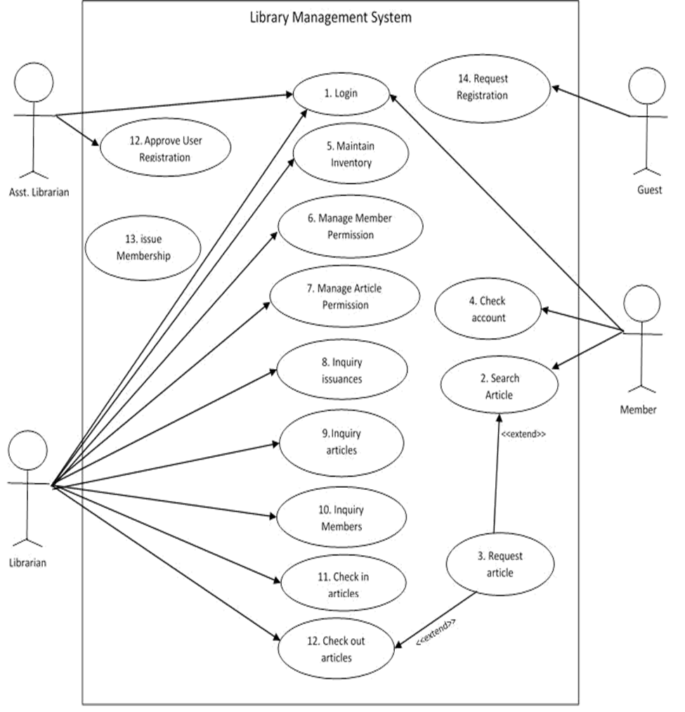
Figure 3.1.2.1 Use case diagram of library management

    - Use-case Scenarios
Login
Abbreviated Title | Login
Actors | Librarian, Members, Asst. Librarian
Description | To interact with the system, LMS will validate its registration with this system. It also defines the actions a user can perform in LMS
Pre-Conditions | User must have proper client installed on user terminal
Task Sequence | - System show Login Screen  - User Fill in required information. Enter user name and password  - System acknowledge entry
Post Conditions | System transfer control to user main screen to proceed further actions
Exception | If in step 3 no user found then system display Invalid user name password error message and transfer control to Task Sequence no.1

Search Article
Abbreviated Title | Search Article
Actors | Member
Description | Search article makes it easy to search for article on LMS. With this search companion, user can specify several search criteria. For example, type, article name, author name, publisher etc.
Pre-Conditions | User must be login
Task Sequence | - System will show searching screen  - User enter required information. It can be user name, book description ISBN etc  - By pressing search button system will list down all searching results
Post Conditions | - User can view his desire results  - User can also request article to reserve for this check use case  - Request article
Exception | If in step 3 no user found then system display Invalid user name password error message and transfer control to Task Sequence no.1

Check Account
Abbreviated Title | Check Account
Actors | Member
Description | System will show member current issued articles, transaction history and their deadlines.
Pre-Conditions | User must be login to the system
Task Sequence | System will display all user history
Post Conditions | User will be on member status screen
Exception | -

Maintain inventory
Abbreviated Title | Maintain inventory
Actors | Librarian
Description | From this use case system will maintain inventory
Pre-Conditions | User must be login with its librarian account
Task Sequence | - System will open Inventory main form  - On this screen librarian can add, update or delete new items to inventory
Post Conditions | System can have updated system inventory
Exception | -

Manage Member Permission
Abbreviated Title | Manage Member Permission
Actors | Librarian
Description | From this user case Librarian can manage user permissions
Pre-Conditions | Member must be logged on with librarian account
Task Sequence | - System show all users registered with LMS  - Librarian will select any user; system will list down all assigned and unassigned permission of current user.  - Librarian can grant or revoke any securities from this screen
Post Conditions | Member will be restricted or granted
Exception | -

    - Activity Diagram
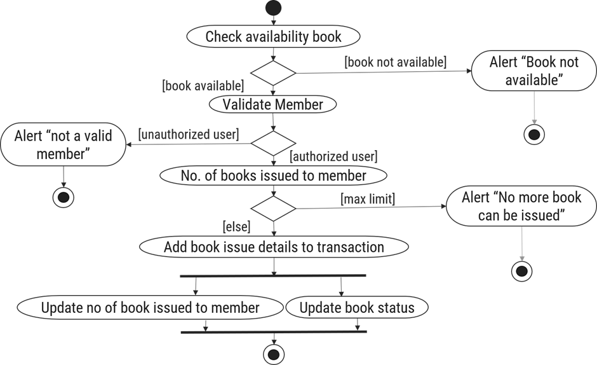
Figure 3.1.4.1 Activity diagram for Book Issue

    - Sequence Diagram
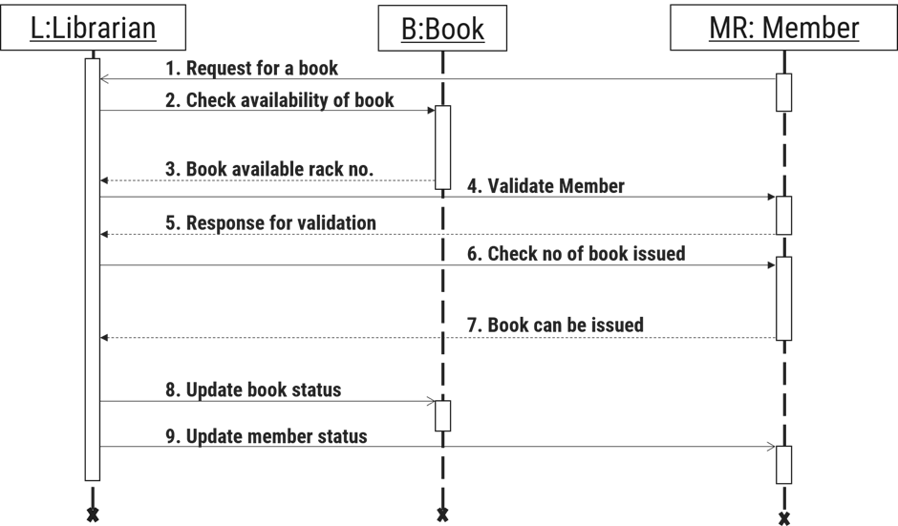
Figure 3.1.5.1 Sequence diagram for Book Issue
    - State Diagram
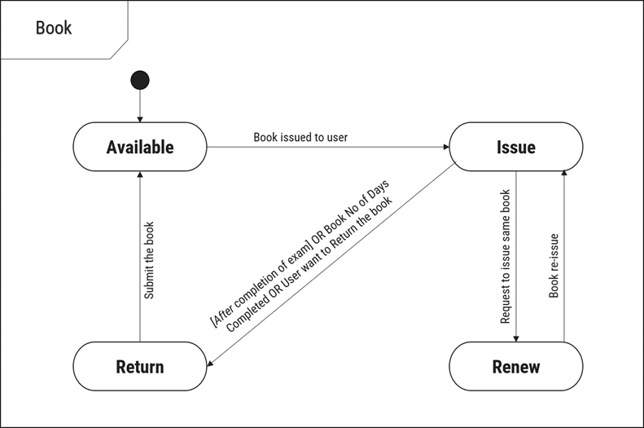
Figure 3.1.6.1 State diagram of Book

    - Class Diagram
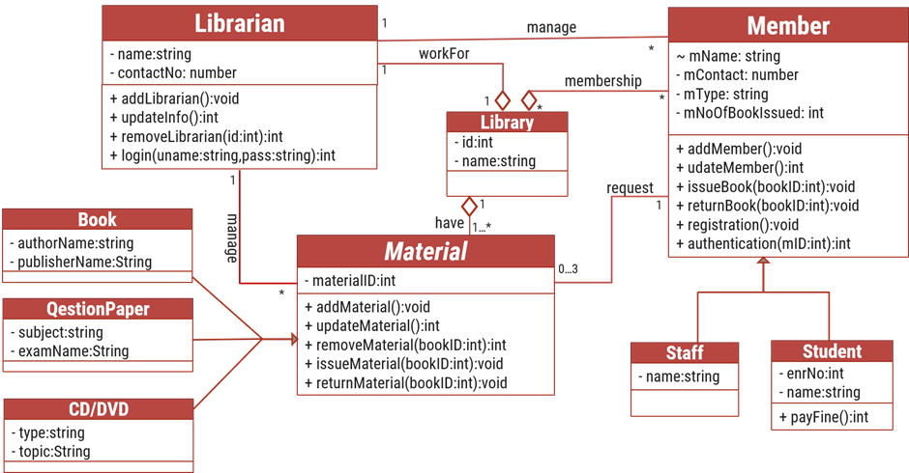
Figure 3.1.7.1 Class diagram of Library Management System

  - Database Design
    - Database Schema
Table 1: Book
Column | Data Type | Null | Keys & Constrains | Default Value & Description
BookID | int | NN | PK (Auto Increment)
BookName | varchar(100) | NN
ISBN | varchar(100) | AN
Publication_year | int | AN
Language | varchar(50) | AN
Table 3.9.1 Table: Book
Table 2: Borrower
Column | Data Type | Null | Keys & Constrains | Default Value & Description
BorrowerID | int | NN | PK (Auto Increment)
BookID | varchar(100) | NN | FK | Reference of Book Table
BorrowedFromDate | DateTime | AN
BorrowedToDate | DateTime | AN
ActualReturnDate | DateTime | AN
IssuedBy | int | NN | FK | Reference of Student and Staff Table
Table 3.9.2 Table: Borrower
Table 3: Staff
Column | Data Type | Null | Keys & Constrains | Default Value & Description
StaffID | int | NN | PK (Auto Increment)
StaffName | varchar(100) | AN
IsAdmin | Boolean | AN
Designation | varchar(100) | AN
Table 3.9.3 Table: Staff
Table 4: Student
Column | Data Type | Null | Keys & Constrains | Default Value & Description
StudentID | int | NN | PK (Auto Increment)
StudentName | varchar(100) | AN
Gender | varchar(100) | AN
DOB | DateTime | AN
Department | varchar(100) | AN
Contact | number(10,0) | AN
Table 3.9.4 Table: Student
    - E-R Diagram

CHAPTER 4
IMPLEMENTATION

  - Module Design and Specification
    - Screen-1: Registration Form

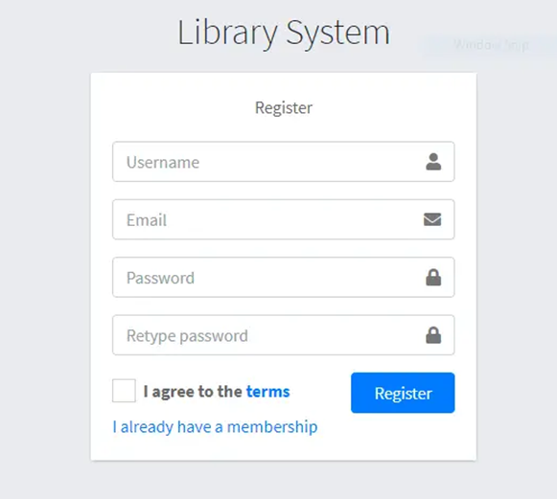
Figure 4.1 1 Screen-1: Registration Form

Purpose: This form will allow the target end-users to register in the system. To register, the following information will be encoded in the system.
Sr. | Screen Element | Input Type | O/M | Description
1 | Username | Textbox | M | Username field should be editable and accept the Username.
2 | Email | Textbox | M | Email field should be editable and accept the email with proper format.
3 | Password | Password | M | Password field should be editable and accept the password and display as star or dot.
4 | Retype password | Password | M | Retype Password field should be editable and accept the password and display as star or dot.
5 | I agree to the terms | Checkbox | M | Checkbox for accepting terms and condition.
6 | I already have a membership | Link | ------ | Link for navigate to login page for registered user.
7 | Register | Button | ------ | Register is a button for store the entered data into database.

Table 4.1 1 Screen element of Registration form
Screen-2: Login Form

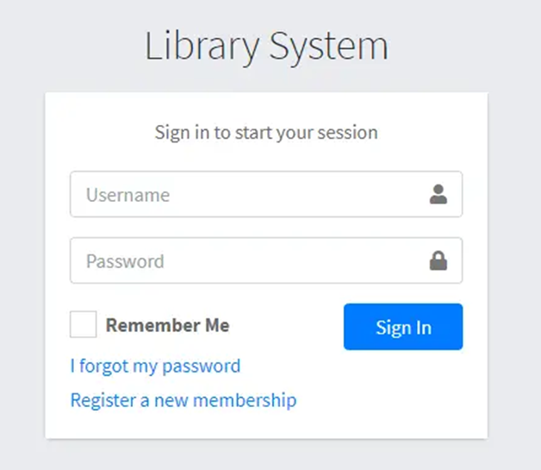
Figure 4.1.2 Screen-2: Login Form

Purpose: This form will be used by the system’s users to access records and features of the system. The users will input the correct combination of their username and password to be able to login to the system.
Sr. | Screen Element | Input Type | O/M | Description
1 | Username | Textbox | M | Username field should be editable and accept the Username.
2 | Password | Password | M | Password field should be editable and accept the password and display as star or dot.
3 | Remember Me | Checkbox | M | Saving login credentials through remember me checkbox
4 | I forgot my password | Link | ------ | Link for navigate to Forgot password page for allows users to recover password.
5 | Register a new membership | Link | ------ | Link for navigate to membership registration.
6 | Sign in | Button | ------ | Login button navigates to another page even if valid login credentials.

Table 4.1.2 Screen element of Login form

    - Screen-3: Add borrower book

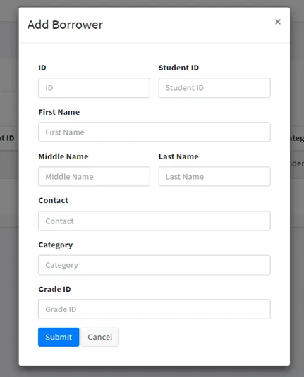
Figure 4.1.3 Screen-3: Add borrower book

Purpose: This module will allow the system administrator to add, edit, update or delete borrowers of book. The admin can add borrower information and manage it.
Sr. | Screen Element | Input Type | O/M | Description
1 | Borrower ID | Textbox | M | Borrower ID field should be editable and fill autogenerated Borrower ID.
2 | Student ID | Textbox | M | Student ID field should be editable and accept Student barcode id.
3 | First Name | Textbox | M | First Name field should be editable and accept only string as a borrower first name.
4 | Middle Name | Textbox | O | Middle Name field should be editable and accept only string as a borrower middle name.
5 | Last Name | Textbox | M | Last Name field should be editable and accept only string as a borrower last name.
6 | Contact | Textbox | M | Contact field should be editable and accept only 10-digit mobile number.
7 | Grade Id | Textbox | O | Auto fetch detail from the database if proper student id is entered.
8 | Submit | Button | ----- | Submit is a button for store the entered data into database.
9 | Cancel | Button | ----- | Cancel is a button for close add borrower dialog.

Table 4.1.3 Screen element of Add borrower book
  - Testing
    - Functional Testing
Test Case ID | Test Scenario | Test Steps | Expected Result | Status
TC001 | User Login | - Open Login Page  - Enter valid username & password  - Click "Login" | User is successfully logged in and dashboard is displayed | Pass
TC002 | Invalid Login | - Enter incorrect credentials  - Click "Login" | Error message displayed: "Invalid Credentials" | Pass
TC003 | Add Doctor | 1. Admin logs in  2. Navigate to "Manage Doctors"  3. Enter doctor details  4. Click "Save" | Doctor record is successfully added | Pass
TC004 | Patient Registration | 1. Registration staff logs in  2. Open "Patient Registration"  3. Enter patient details  4. Click "Register" | Patient is successfully registered | Pass
TC005 | Add Prescription | 1. Doctor selects patient  2. Enter prescription details  3. Click "Save Prescription" | Prescription is saved successfully | Pass
TC006 | Request Lab Test | 1. Doctor selects patient  2. Choose lab test  3. Submit request | Lab test request is successfully generated | Pass
TC007 | Update Lab Test Result | 1. Lab staff logs in  2. Select patient test request  3. Enter test result  4. Click "Update Result" | Lab test result updated successfully | Pass
TC008 | Process Payment | 1. Billing staff opens patient bill  2. Enter payment details  3. Click "Confirm Payment" | Payment recorded successfully | Pass
TC009 | View Lab Report | 1. Doctor logs in  2. Doctor opens patient record  3. Select "Lab Reports" | Lab report details are displayed | Pass
TC010 | Logout | Click on "Logout" button | User is logged out and redirected to login page | Pass

    - Non-Functional Testing
Test Case ID | Test Scenario | Test Steps | Expected Result | Status
TC011 | Load Testing | 1. Simulate 100+ concurrent users  2. Perform patient registration, appointment booking, and record viewing | System should handle multiple users without crashing, response time ≤ 2 seconds | Pass
TC012 | Security Testing | Attempt SQL Injection in login field | System should prevent SQL Injection | Pass
TC013 | Performance Testing | 1. Access patient records  2. Generate prescriptions and bills | System operations should complete quickly without delays | Pass
TC014 | Usability Testing | - Test UI for ease of use  - Check accessibility for users | Users can navigate easily, UI is clear | Pass
TC015 | Authentication Testing | 1. Login with valid credentials  2. Login with invalid credentials | System should allow valid users and block invalid users | Pass
TC016 | Compatibility Testing | Open system in Chrome, Firefox, and Edge browsers | System should work properly on all supported browsers | Pass
TC017 | Role-Based Access Testing | 1. Login as Admin, Doctor, Lab Staff, Billing Staff  2. Try accessing restricted modules | Users should only access modules assigned to their roles | Pass

CHAPTER 5
CONCLUSION AND FUTURE ENHANCEMENT

  - Conclusion
The Hospital Management System developed in this project successfully digitizes the traditional hospital management process by providing an efficient and organized platform for managing hospital operations. The system simplifies tasks such as patient registration, appointment scheduling, doctor consultation, laboratory test management, patient admission and discharge, and billing. By automating these processes, the system reduces manual paperwork, minimizes human errors, and improves the overall efficiency of hospital administration.

Through this project, we have demonstrated how technology can enhance healthcare management by integrating different hospital departments into a single system. The system provides a user-friendly interface for various roles such as Admin, Registration Staff, Doctor, Lab Staff, and Billing Staff, enabling them to perform their tasks effectively. By maintaining a centralized database for patient records, prescriptions, laboratory reports, and billing information, the system ensures better data management and faster access to information. Overall, the Hospital Management System improves operational efficiency, enhances coordination among hospital staff, and provides a reliable digital solution for modern healthcare management.

  - Future Enhancement
While the current system covers the fundamental aspects of library management, several enhancements can be made to improve its functionality and user experience:

- Mobile Application Integration
A mobile application can be developed for Android and iOS platforms so that hospital staff and patients can access the system easily. Through the mobile app, patients can check appointments, view prescriptions, and receive notifications related to their medical reports and billing.

- Online Appointment and Notification System
The system can be enhanced to allow patients to book appointments with doctors online. Additionally, automated notifications through email or SMS can be implemented to inform patients about appointment confirmations, laboratory results, and billing updates.

- Advanced Reporting and Analytics
Future versions of the system can include advanced reporting and analytics features. These reports can help hospital management analyse patient data, doctor performance, laboratory activities, and billing statistics, which will assist in better decision-making and hospital management.

APPENDICES

Appendix A: Acronyms and Abbreviations
Acronym | Full Form
HMS | Hospital Management System
MERN | MongoDB, Express.js, React.js, Node.js
DBMS | Database Management System
UI | User Interface
HTML | HyperText Markup Language
CSS | Cascading Style Sheets
JS | JavaScript
React.js | JavaScript Library for building User Interfaces
Bootstrap | Frontend Framework for Responsive Web Design
API | Application Programming Interface
REST API | Representational State Transfer Application Programming Interface
JSON | JavaScript Object Notation
IPD | In-Patient Department
OPD | Out-Patient Department
CRUD | Create, Read, Update, Delete
Context | A broad level diagram of the project showing a basic overview
Use Case | summarizes some of the relationships between Cases, user, and systems.
UML | Unified Modelling Language

REFERENCES
[1] Kapil B. Patil, Software Requirement Specification Document, LinkedIn Corporation, Sunnyvale USA,2018, www.slideshare.net /ANASNAIN/17337071 srslibrarymanagementsystem

[2] Karl E. Wiegers, IEEE Standard Of SRS Document, IEEE, web.cs.dal.ca/~hawkey/3130/srs_template-ieee.doc

[3] Roger S. Pressman, Software Engineering, McGraw-Hill, IA New York,2010. www.processimpact.com/process_assets/srs_template.doc.

